P.3 Literacy II

# THEME: OUR ENVIRONMENT IN OUR SUB COUNTY ENVIRONMENT

* It is the man and his surroundings.
* These are things that surround us. Components of our environment

These are things that make up the environment e.g land/soil, water, air, plants, animals e.t.c

Living things are things that carry out life processes Characteristics

* They feed
* They reproduce
* They move/locomote
* They respire
* They grow
* They respond to stimulus

Non living things are things which do not carry out life processes Characteristics

* They do not feed
* They do not reproduce
* They do not respond to stimulus
* They do not move
* They do not grow

## Activity

1. *Explain the word environment.*
2. *Give any three components of the environment.*
3. *What is the difference between living and non living things.*
4. *Give nay three characteristics of things which do not carry out life’s*

*processes.*

1. *State any four characteristics of non living things.*

# LESSON 2: SOIL

Soil is the top layer of the earth’s surface where plants grow and get support.

Components of soil

* Air
* Water
* Mineral salts
* Rock particles
* Humus
* Living organisms (organic matter)

# Experiment to show that soil contains humus

*Requirements*

* Sample of soil
* Beaker/jug
* Water

*Procedure*

* 1. Get a transparent jug with water.
  2. Put soil in the water and stir

*Observation*

1. Humus will settle on top surface of water.

floating humus



water

soil sample

1. Humus is formed when plants and animals die and decay.

Importance of humus

* It adds fertility to the soil (it makes the soil fertile).
* It holds the soil particles together.
* It keeps the soil water for along time.
* It determines the colour of the soil

## Activity

1. *What is soil?*
2. *Identify any four components/things the makeup soil.*
3. *How is humus formed?*
4. *State three importance of humus to the soil.*

# LESSON 3: AIR AS COMPONENT OF SOIL

Air is a mixture of gases.

How is air useful in the soil/to plants?

* Oxygen supports seed germination
* Nitrogen gas is converted into plant nitrates by nitrifying bacteria nitrogen fixing bacteria found in root nodules.
* Plants use carbon dioxide for photosynthesis.

# Experiment to show soil contains air

*Requirements*

* Samples of soil
* Jug/beaker
* Water

*Procedure*

* Get a transparent jug with water
* Pour soil in the water

*Observation*

* Air bubbles will be seen coming out



water

air bubbles soil sample

*Conclusion*

* Soil contains air

Examples of creatures in the soil

* Earthworms
* Land snails
* Termites
* Porcupines
* Millipedes
* Bacteria
* Rats
* Squirrels
* Centipedes

Examples of mineral salts in the soil

* Iron
* Calcium
* Phosphorus
* Zinc
* Nitrates
* Magnesium

## Activity

1. *Define the term air.*
2. *Give three uses of air to plants.*
3. *Write down the creatures that live in the soil.*
4. *In which way are living organisms useful in the soil?*

# LESSON 4: WATER

Water is a colourless common liquid found on earth and it supports life.

Water is formed from;

* Swamps
* Wells
* Boreholes
* Oceans
* Seas
* Rivers\spings
* Lakes
* Dams e.t.c

Uses of water in the soil

* Helps in seed germination.
* It is a raw material for photosynthesis.
* It dissolves mineral salts making it easy for plants to absorb/suck them.
* Water cods plants through transpiration.

# Experiment to show that water is contained in soil

*Requirements*

* Samples of soil
* Stove
* Match box
* Pans

*Procedure*

* Light the stove.
* Put the soil in the pans.
* Put the pans on the burning stove.

*Observation*

* Vapor will be seen on the lid



steam

soil sample

heat

*Conclusion*

* Soil contains water

## Activity

1. *Water is said to be a common liquid on earth. Identify any four sources of water.*
2. *Write down three uses of water in the soil.*
3. *State the main natural source of water in the environment.*

# LESSON 5: MINERAL SALTS

Mineral salts form plant food and they are absorbed/sucked by plant roots hence making the plant healthy and strong.

Examples of mineral salts in the soil

* Magnesium
* Iron
* Calcium
* Potassium
* Nitrates
* Prophorous
* Zinc e.t.c

**Weathering**

This is the breakdown of rocks into smaller particles to form soil.

1. Physical weathering

This is the breakdown of rocks by the action of force.

1. Chemical weathering

This is the breakdown of rocks as a result of chemical reactions with other substances.

Soil is therefore a mixture of weathered rock particles and organic matter.

## Activity

* 1. *State why mineral salts are important to plants.*
  2. *Give four examples of mineral salts found in the soil.*
  3. *What is weathering?*
  4. *Name two types of weathering.*
  5. *Name the mineral that help our teeth and bones to develop stronger.*

**Decomposition**

This is the rotting of dead animals and plants by the action of the bacteria. It helps in the formation of humus in the soil.

# LESSON 6: TYPES OF SOIL

There are three types of soil. Namely;

1. Loam soil
2. Clay soil (clayey)
3. Sand soil (sandy soil)

***Illustration of soil types***



clayey soil loam soil sandy soil

Characteristics of loam soil

* Loam soil is a mixture of humus, sand and clay/clayey.
* It is rich in humus hence making it fertile.

Characteristics of sandy soil

* It has large air spaces.
* It has big sand particles.
* It is loose, light and easy to plough (dig).
* It has a good drainage (it allows water to pass through easily)
* It is not fertile.
* It dries easily in hot weather.

## Activity

* 1. *Name the three types of soil.*
  2. *Give four differences between loam soil and sand soil.*

# LESSON 7: TYPES OF SOIL

Characteristics of clay soil

* Soil particles are held together.
* It is heavy and sticky.
* It is difficult to dig.
* It has small air spaces.
* It doesn’t allow water to pass through easily.
* It is water logged (retains a lot of water).

# Uses of soil

* It supports plant growth (loam soil).
* For molding cups, plates e,t,c (clayey).
* For construction of houses, roads and bridges. (sand).
* For making glasses (sand soil).
* We sell soil and get money.
* For brick laying.
* Some animals live in soil as their habitat.

## Activity

1. Give any three characteristics of clay soil.
2. Identify the type of soil used for;
   1. Molding cups, plates
   2. Growing crops
   3. Construction of houses, bridges
3. Mention four uses of soil to man.
4. Which type of soil has;
   1. Poor aeration
   2. Good drainage
   3. Rich in humus content

# WEEK TWO

**LESSON 1: SOIL PROFILE/COMPOSIT PILE/PIT**

Soil profile is the verticle arrangement of soil layers from top to bottom. Illustration of soil profile

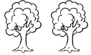

Top soil/Top layer Sub soil

Parent rocks

1. Top soil
   * It is a very important layer because it has lot of humus and mineral salts that plants need.
   * It is dark in colour due to a lot of humus.
   * It’s the best layer for plant growth.
2. Sub soil
   * It is thick, light brown in colour with no creatures.
   * It is poorly aerated and very infertile.
3. Parent rocks

* These are big rock particles found beneath/under the ground.
* They are sources of minerals.
* They are crushed for construction.
* They form soil when weathered.
* Trap underground water.
* Sources of fossil fuels.

## Activity

1. *What is soil profile?*
2. *Which layer is dark in colour and is rich in humus?*
3. *Which layer is the source of minerals and traps underground water?*
4. *Draw and name all the soil layers.*

# LESSON 2: SOIL EROSION

This is the removal of top soil by its agents.

Agents of erosion

These are factors that help soil erosion to take place. Examples are;

* Flowing water
* Wind (moving air)
* Moving animals

Types of soil erosion

# Sheet erosion

This is a type of erosion which takes place in flat area and soil is uniformly removed.

# Splash erosion

This is the type of erosion which takes place in bare ground. It removes soil by splashing it away by water droplets.

# Rill erosion

This is where small and shallow ditches are dug by the flowing water.

# Gulley erosion

This is where bigger and deeper ditches are dug by the flowing water.

## Activity

* 1. *What is soil erosion?*
  2. *Name three agents of soil erosion.*
  3. *Identify any three types of soil erosion.*
  4. *What do we call the type of soil erosion where soil is removed by water droplets that splashes soil away from a bare ground?*

# LESSON 3: CAUSES OF SOIL EROSION

* Deforestation
* Bush burning
* Monocropping / monoculture
* Overgrazing
* Over cultivation

Control of soil erosion

These are control measures suggest the ways through which soil erosion can be controlled.

* Afforestation
* Intercropping/mixed cropping
* Contour ploughing
* Crop rotation
* Mulching
* Terracing

## Activity

1. *What is;*
   1. *Soil erosion?*
   2. *Deforestation?*
   3. *Mulching?*
2. *State four causes of soil erosion.*
3. *Suggest four ways to control soil erosion.*

# LESSON 4: SOIL EXHAUSTION

Soil exhaustion is the loss of soil fertility.

Soil fertility is the ability of the soil to support plant life. Causes of soil exhaustion

* Bush burning
* Monocropping/monoculture
* Over cultivation
* Bush burning
* Deforestation

## Activity

1. *Explain the following terms;*
   1. *Soil exhaustion*
   2. *Soil fertility*
2. *Mention any four bad farming practices that can result into soil being infertile.*
3. *Define the following;*
   1. *Monoculture*
   2. *Over grazing*
   3. *Deforestation*

# LESSON 5: SOIL CONSERVATION

Soil conservation is the practice of maintaining soil fertility.

Soil fertility refers to the ability of the soil to produce and sustain high crop yields indefinitely.

How to conserve soil

To conserve means to use something sparing so that it lasts for long.

**Soil can therefore be conserved in order to retain its fertility in the following ways;**

* Practice crop rotation
* Mulching
* Bush fallowing
* Terracing in hilly areas

## Activity

1. *What is soil conservation?*
2. *What term describes the ability of the soil to produce and sustain high yields?*
3. *Mention any four ways to conserve soil.*
4. *Suggest three reasons why we should conserve soil.*

# LESSON 6: CHANGES IN THE ENVIRONMENT

1. Natural changes
2. Man-made changes

# NATURAL CHANGES

Natural changes are changes that occur and exist by nature. Examples of these changes include;

* + Volcanic eruption\landslides
  + Changes in weather
  + Changes in seasons
  + Growth in plants and animals

Effects/dangers of natural changes

* Hunger
* Destruction of homes
* Soil erosion
* Disease outbreaks
* Migration
* Destruction of life

Ways of managing these changes

* Planting more trees
* Graze few animals
* Conserve wetlands
* Carryout rural electrification to reduce deforestation

## Activity

1. *Name the two types of changes in the environment.*
2. *What are natural changes?*
3. *Write down four examples of natural changes.*
4. *Identify three dangers of natural changes.*
5. *Suggest three ways of managing natural changes.*

# LESSON 7: MAN – MADE CHANGES

Man made changes are changes that take place due to man’s influence.

Examples are;

* Fishing
* Building houses
* Making furniture
* Swamp reclamation
* Making medicine from plants
* Construction of roads
* Making of vehicles
* Cutting down trees
* Growing crops e.t.c

Good effects of man made changes

* They bring new and nice look to our environment
* We get food through farming
* Easy treatment due to medicines made
* Easy transport system due to good roads and vehicles manufactures.
* Clean water for human use due to wells and boreholes built.

Bad/negative effects of man made changes

* Pollution from smoke in industries
* Soil erosion due to bush burning
* Drought due to deforestation and swamp reclamation
* Homeless of wild animals

## Activity

1. *What are man-made changes?*
2. *Give four examples of changes caused due to man’s activities.*
3. *Identify four good effects of man – made changes.*
4. *Write down two negative effects of man – made changes in the environment.*

# THEME: ENVIRONMENT AND WEATHER IN OUR SUB-COUNTY LESSON 1: AIR

Air is a mixture of gases.

Wind is the moving air / Wind is air in motion.

Components of air

Air is composed of the following gases;

* Oxygen (21%)
* Nitrogen (78%)
* Carbondioxide (0.03%)
* Rare gases (0.97%)

## Activity

1. *Explain the term;*
   1. *Air*
   2. *Wind*
2. *Write down four components of air.*
3. *Name the gas which takes;*
   1. *The highest percentage in air.*
   2. *The lowest percentage in air.*
4. *Name two gases found in the group of rare gases.*

# LESSON 2: PROPERTIES OF AIR

* Air has weight
* Air occupies space
* Air exerts pressure
* Air can be compressed
* Air can be felt

*Experiment show that air has weight*

A baloon with Enough air

A ballon with less air

*Experiment to show that air occupies space*

air



bubbles water

*Experiment to show that air exerts pressure*

rd paper



water

ha

*Experiment to show that air can be compressed*

heavy object



balloon with air

ground

# LESSON 3: MEASUREMENTS OF AIR PRESSURE

* Air pressure is measured using an instrument called barometer.
* Air pressure is a force exerted by air columns on an object.

*Structure of a barometer*

Mercury barometer



Uses of air

* Oxygen supports germination of seeds.
* Oxygen is needed for rusting to take place.
* Wind turns wind mills.
* Air helps to dry clothes.
* Carbondioxide helps plants to make food.
* Carbondioxide helps in preservation of drinks.
* Air is used to play games like flying kites.

## Activity

1. *What do we call the force exerted by air on an object?*
2. *Name the instrument used to measure air pressure.*
3. *Outline four uses of air.*

# LESSON 4: DANGERS OF AIR

* Storms kill people
* Strong winds blow off roofs of houses
* Air spreads air borne diseases
* It makes boats to capsize/over turn
* Carry dust into our eyes
* Oxygen makes metals rust
* Strong winds break trees

Rusting is the turning of iron metals reddish brown in the presence of oxygen and water.

Dangers of rusting

* It makes sharp edges of metals blunt.
* Metals develop holes and become weak and they also leak.
* Metals become wasted.

## Activity

1. *State three dangers of air to us.*
2. *Define rusting.*
3. *Name two conditions necessary for rusting to take place.*
4. *List two dangers of rusting.*
5. *Suggest two ways of control rusting metals.*

# LESSON 5: THE SUN

Uses of the sun

* Provides heat energy
* Provides light
* Helps plants to make their own food
* Provide heat for vitamin D formation
* Heat from the sun kills some germs/vectors
* Helps in the formation of rainfall
* Heat from the sun helps to dry our seeds and clothes.

Disadvantages of the sun

* A lot of sunshine makes the day hot.
* Prolonged sunshine dries up the soil making it hard
* Prolonged sunshine dries up water bodies.

## Activity

1. *Define energy.*
2. *Give four examples of natural sources of energy.*
3. *List five uses of the sun to our environment.*
4. *Mention two reasons why the sun is dangerous to us.*

# LESSON 6: WIND

Wind is the moving air (it is the air in motion)

Advantages of wind

* Helps to bring cold air in warm places
* Helps in pollinating plants
* Helps in winnowing
* Helps in the formation of rainfall
* It sails boats
* It flies kites
* It dries wet things like paint, decorated cakes, clothes

Disadvantages of wind

* It spreads air borne diseases like mumps, tuberculosis.
* It is an agent of soil erosion.
* It throws down houses trees and crops.
* It causes storms on land and water bodies that leads boats to capsize.

## Activity

1. *What do we call the air in motion?*
2. *How is wind important to farmers? (Give two)*
3. *Mention other four ways how is wind is dangerous to our community.*

# LESSON 7: WATER

Advantages of water

* It is used for domestic purpose i.e cooking, mopping, drinking, washing, scrubbing flour.
* It is used for watering crops.
* It is used for transport.
* It is used to cool machines.
* It is used for swimming.
* It supports plant growth.

Disadvantages of water

* It causes accidents like near drowning.
* It can lead to rotting of crops if its too much in the soil.
* It spreads diseases.
* Running water takes away crops.
* Running water causes soil erosion.

## Activity

1. *Give five ways how water is important at home.*
2. *Mention other four importance of water apart from being used at home.*
3. *List four disadvantages of water.*

# LESSON 1: PLANTS

Uses of plants

* Some plants act as food.
* They are sources of wood.
* They are sources of poles.
* We get timber.
* They provide shade.
* They control soil erosion.
* They act as wind breakers.
* Some plants act as herbal medicine.

Dangers of plants

* Some plants pierce animal’s skin like rose flower, cactus, thorn plants.
* Some plants are poisonous.
* Some plants have bad smell and cause skin infection.

## Activity

1. Name three ways how plants are important at our school.
2. Give two ways how plants are useful to our environment.
3. Mention two things in our class that are made from plants.
4. How are plants dangerous to us? Give two reasons

# LESSON 2: ANIMALS

Uses of animals

* Some animals are used for transport.
* Some animals provide us with milk.
* They provide skins and hides.
* They provide feathers, hooves and horns.
* Some animals are used for ploughing.
* Some animals provide security.
* Cats eat mice and rats.

Dangers of animals

* Some animals can kill and eat people like lions.
* Some animals are pests to crops.
* Some animals are vectors that spread germs.

## Activity

1. Name the animals that provide the following roles;
   1. Transport
   2. Milk
   3. Ploughing
   4. Security
2. Name the two kinds of food we get from animals.
3. How are animals dangerous to man? (Give two)

# LESSON 1: TYPES OF CLOUDS

A cloud is a condensed water vapour.

There are four types of clouds.

# Stratus

These are thick and grey covering large parts at the sky.

# Cirrus

These are thin and wispy. They appear at high altitudes. They are the highest clouds that appear like feathers.

# Cumulus

These are big, dark clouds with white particles. They look like cotton wool and have flat bases.

# Nimbus

These are big, dark clouds they are associated with rain. They don’t have

the white patches and flat base of the cumulus.

|  |  |
| --- | --- |
| **Cloud** | **Weather** |
| * Cirrus * Stratus * Cumulus * Nimbus | Sunny/windy Sunny/windy Cloudy/rainy Cloudy/rainy |

## Activity

* 1. *What are clouds?*
  2. *Name four types of clouds.*
  3. *Which cloud appears at the highest altitude?*
  4. *Identify the type of clouds that are friendly to farmers.*

# LESSON 2: EFFECTS OF CLOUDS

* Bring rain (nimbus)
* Cool temperatures (cumulus/nimbus)
* Shield us from strong sun heat
* Thick clouds trap heat energy causing rise in temperature (cumulus)
* Shade off sunlight (darkness)
* Can contain hailstone which is destructive.
* Can result into lighting.

Measurement of rainfall

Rainfall is the amount of rain water received in an area. It is measured using a rain gauge.

Rain gauge

funnel



(It directs water into the bottle)

metal container

(prevents water from evaporating)

## Activity

water bottle

(it collects the amount of rainfall received)

1. *Give four effects of clouds in the environment.*
2. *Name the instrument used to measure rainfall.*
3. *State the function of a water bottle in the rain gauge.*

# LESSON 3: EFFECTS OF RAINFALL

Rain is a condensed vapour in the atmosphere.

Uses of rainfall

* Water for domestic activities
* Water for crop growing
* Water for photosynthesis in plants
* Helps in seed germination
* Softens the soil
* Cools the environment

Dangers of rainfall

* Destruction of property like houses
* Causes flooding (drowning)
* Destroys crops
* Causes soil erosion
* Spoils road surfaces and bridges
* Lighting and thunder
* Spreads diseases e.g water borne diseases
* Causes land slides

**N.B:** Humidity is the amount of water vapour in atmosphere. It is measured using hygrometer.

## Activity

* 1. *What is humidity?*
  2. *Name the instrument used to measure humidity.*
  3. *Suggest four uses of rainfall.*
  4. *Identify any four dangers of too much rainfall.*

# LESSON 4: SOURCES OF WATER

Water is the most common liquid on earth and it supports life. Location of water sources

These refer to places from where we get water.

1. Natural source

* Rain
* Lakes
* Swamps
* Oceans
* Rivers
* Seas
* Mountain surfaces

1. Artificial/man – made sources

* Springs
* Wells
* Boreholes
* Valley dams

Properties of water (universal solvent)

* Has the highest capacity
* Boils at 1000C and cools at 00C
* High surface tension
* It is transparent

## Activity

* 1. *Name any four natural sources of water.*
  2. *Name any four artificial sources of water.*

# LESSON 5: HARVESTING WATER

We can harvest water for domestic use and other uses away from home.

We use these items for collecting/harvesting water

* Buckets
* Pails
* Jerrycans
* Pots
* Tanks
* Basins
* Saucepans e.t.c

General uses of water to man

* For domestic use like cooking, washing, bathing
* For mixing motor (sand & cement + stone) for construction
* Watering crops/irrigation
* For fishing
* For cleaning the environment
* Distilled water is used in hospitals
* Means of transport
* Water is a coding agent
* For hydro electricity

Uses of water to plants

* Raw material for photosynthesis
* Cools the plant through transpiration
* For seed germination, agent of seed dispersal
* Supports life of aquatic plants

## Activity

1. *Name four items used to collect/harvest water.*
2. *Identify five uses of water to man*
3. *Suggest four ways by which plants use water.*

# LESSON 6: WATER CONTAMINATION

Water for human use needs to be clean and safe.

It should be free from germs and minerals and is not harmful to support life. Water contamination is making water dirty.

Water gets dirty/contaminated through:-

* Use of dirty containers.
* When we swim and bathe in water sources.
* When animals drink from water sources and urinate in water.
* When we throw rubbish in water.
* Disposal of industrial wastes into water.
* Pouring agricultural chemicals into water.
* Building latrines near water sources
* Washing clothes in water sources.

How water sources can be kept clean

* Use clean containers.
* Don’t swim and bathe in water sources.
* Don’t take animals to drink from water source.
* Don’t pour rubbish in/near water sources.
* Avoid pouring chemicals in water.
* Water sources should be fenced.
* Remove weeds from water sources.

## Activity

1. *What do we mean by water contamination?*
2. *Write down five ways through which water gets contaminated.*
3. *Suggested four ways through which water sources can be kept clean.*

# LESSON 7: LIVING THINGS IN THE ENVIRONMENT

* Insects e.g bees, houseflies, cockroaches, tsetseflies
* Birds e.g ducks, pegion, weaver birds, eagle, owl
* Animals e.g lion, elephants, cows, dogs, leopards
* Fish e.g tilapia, nile perch, mud fish, shark

Characteristics of living things

* They respire
* They reproduce
* They feed
* They move/locomote
* They grow/develop
* They respond to stimuli
* They excrete

## Activity

1. *Explain the term environment.*
2. *Name two groups of animals in the environment.*
3. *Give three examples of animals which belong to;*
   1. *Insects*
   2. *Birds*
   3. *Fish*
4. *List four characteristics of living things.*

# LESSON 1: CLASSES OF ANIMALS

While animals are grouped into two types i.e wild and domestic animals. They are also classified into the following classes.

1. Animals in air

These fly and spend good amount of time in air e.g insects, birds

1. Animals in water

Fish, frogs, crocodile, tortoise.

1. Animals on land

Goats, lions, land snails, elephants, man, earthworms, squirrels, monkeys.

## Activity

* 1. *Name the two types of animals.*
  2. *State the difference between wild and domestic animals.*
  3. *Identify three examples of animals that live in:*
     1. *Air*
     2. *Water*
     3. *Land*

# LESSON 2: TYPES OF ANIMALS

We have two types of animals.

1. Domestic animals (domesticated)
2. Wild animals (non domesticated)

**Domestic animals**

These are animals that are kept and cared for by man at home e.g cows, donkey, goats, dogs, sheep, cats, rabbits.

How to care for domestic animals

* You feed them and provide water
* You provide them with shelter
* You clean their shelter
* You provide medical care/vaccinate them

## Activity

* 1. *Identify two types of animals.*
  2. *What are domestic animals?*
  3. *Give four examples of domestic animals.*
  4. *State four ways through which we can care for domestic animals.*
  5. *Name the first animals to be domesticated by man.*
  6. *Suggest two reasons why man keeps a dog at home.*

# LESSON 3: WILD ANIMALS

These are non-domesticated animals that live in the bush/forest e.g giraffe, leopards, lion, elephants, antelopes, monkey, wild, rabbit, baffalos, zebra e.t.c

Uses of wild animals to man

* For future generation to see and benefit from.
* Raw materials for manufacturing some materials.
* Provides field of study.
* Sources of foreign exchange through tourism.
* Store genes for related animals to domestic animals.
* Sources of food (meat).

Problems facing wild animals

* Poaching (illegal hunting and killing)
* Diseases may kill them
* Political instability which leads to destruction of their habitats.
* Encroachment like settlement, farming, industrial

How to care for wild animals

* Avoid unnecessary killing
* Vaccination of wild animals
* Keep them in game parks/reserves and zoos
* Set laws by government to protect wild life.

## Activity

1. *What are wild animals?*
2. *Give four examples of wild animals?*
3. *State any three ways through which we can care for wild animals.*

# LESSON 4: CHARACTERISTICS OF ANIMALS

1. Birds

* They lay eggs
* They have feathers
* They are warm blooded
* They have internal fertilization
* They have wings
* They have streamlined body shape
* They respire through lungs
* They have scales on their feet

1. Insects

* They have three main body parts
* They have 3 pairs of legs
* They breathe through spiracles
* They have a pair of compound eyes

## Activity

* 1. *State any six characteristics of birds.*
  2. *Give any four characteristics of insects.*
  3. *Mention two uses of insects to people.*

# LESSON 5:

1. Fish

* They use fins for protection.
* Use nostrils for smelling and tasting food
* Have streamlined body shape.
* They are cold blooded
* They have no external ears.
* They breathe through gills.
* They undergo external fertilization
* Have slimy and slipperly skin covered with scales
* Don’t care for youngones.

1. Animals with four legs

* Their body is covered with fur.
* They are warm blooded.
* They undergo internal fertilization.
* They breathe through lungs.
* Their heart is divided into 4 chambers.
* They care for their young ones by breast feeding.
* They produce live young ones.

Products we get from animals

* Skins and hides
* Meat
* Milk
* Bones
* Hooves
* Horns
* Wool
* Blood

## Activity

* 1. *Give six characteristics of fish.*
  2. *Write down four characteristics of animals with 4 legs (limbs).*
  3. *Mention four products we get from animals.*

# LESSON 6: HABITATS

A habitat is a place where an organism lives in. It is a home of a living thing. Different animals/organisms lives in different habitats depending on the suitability of the home.

|  |  |
| --- | --- |
| **Animal** | **Habitat** |
| Cat Pig Cattle Horse Goat Lion  Wild rabbit Domestic rabbit Rat  Crocodile Snail Dog  Chameleon Termites Fish  Bees White ants  Spider | Basket Sty  Kraal/shed/byre Stable  Shed/pen Den Burrow Hutch  Burrow/nests Water/land Land/water Kennel Forest/trees Ant hills Water  Hive Ant hill  Cob web |

## Activity

1. *What is a habitat?*
2. *Name the habitat of the following animals.*
   1. *Lion*
   2. *Rat*
   3. *Domestic rabbit*
   4. *Horse*
   5. *Fish*
3. *Which animal live in the following habitats?*
   1. *Sty*
   2. *Burrow*
   3. *Ant hill*
   4. *Kennel*
   5. *Basket*
   6. *Hive*

# LESSON 7: CATEGORIES OF ANIMAL HABITATS

1. Garden/field

Animals found in the garden/field include;

* Squirrels
* Monkeys
* Rats
* Chameleon
* Bees
* Tortoise
* Slugs
* Earthworms
* Landslides\butterflies e.t.c

1. School compound

Animals found in school compound include;

* Cows
* Rabbits
* Pigs
* Dogs
* Chicken
* Sheep
* Goats
* Cats
* Lizards
* Gecko e.t.c.

1. Swamp/wetlands

A swamp is a vegetated water logged area. Animals that are found in swamps include;

* Frogs
* Fish
* Slugs
* Crocodile
* Egret
* Ducks
* Toads
* Snakes\tortoises
* Hippopotamus
* Mosquitoes e.t.c.

1. Ponds

It’s a small pool of water collected in one place. Animals in ponds include;

* Fish
* Water snails
* Mosquitoes
* Worms
* Frogs
* Slugs
* Black flies
* Tortoise

## Activity

* 1. *Identify four animals that can be found in;*
     1. *Garden/field*
     2. *School compound*
     3. *Swamp/wetland*
  2. *What is;*
     1. *A swamp?*
     2. *A pond*
  3. *Give three examples of animals that live in a pond.*

# LESSON 1: AQUARIUM

An aquarium is a large glass container in which fish and other water creatures are kept.

An aquarium is a building where people can go and see fish and other water creatures.

Examples of animals that can be kept in an aquarium;

* Fish
* Water snails
* Tortoises
* Snakes
* Turtles e.t.c

**Parts of a fish**

lateral fin

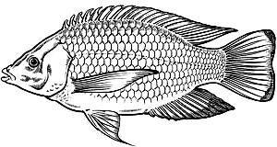

dorsal fin

nostril

tail fin

## Activity

gill cover

pectoral fin

pelvic fin

anal fin

1. *What is an aquarium?*
2. *Write down four examples of animals that can be kept in a aquarium.*
3. *Draw a diagram of a fish and show the gill cover, scales, tail fin, dorsal fin, lateral line*

# LESSON 2: FUNCTIONS OF PARTS OF A FISH

|  |  |
| --- | --- |
| **Part** | **Function** |
| Nostril | - For smelling and tasting food. |
| Scales | - Protect the skin of a fish. |
| Eyes | - For seeing. |
| Dorsal fin | - For protection against enemies. |
| Lateral fin | - For detecting danger and sensing sound waves. |
| Tail | - For steering movement and making corners. |
| Gill cover | - Protects the gills from damage. |
| Mouth | - For getting in food/letting in water during the breating |
| Gills | - For breathing. |
| Swim bladder | - For balancing in water. |
| Pectoral and pelvic fin | - For breaking speed to go upward and downward in water. |

## Activity

1. *State the function of the following;*
   1. *Lateral line*
   2. *Dorsal fin*
   3. *Nostril*
   4. *Swim bladder*
2. *Which part of a fish performs the following roles;*
   1. *Protect the skin of the fish*
   2. *For breathing*
   3. *Steering and making corners*
   4. *For getting/picking food*

# LESSON 3: BIRDS

There are two types of birds

1. Domestic birds
2. Wild birds

Domestic birds

Are birds kept at home and cared for by man. E.g. chicken, duck, turkey, guinea fowl, pigeon, e.t.c.

Wild birds

Are birds that live in the bust and are not cared for by man. E.g. eagles, weaver birds, owl, scavenger birds, e.t.c.

Birds that cannot fly

* They have small wings and heavy bones e.g. kiwi, emu, ostrich, penguin

Importance of birds to man

* Provide eggs
* Provide meat
* Provide feathers for decoration
* We sell and get money
* Droppings are used as manure
* Some birds pollinate flowers

## Activity

1. *Name two types of birds.*
2. *Give examples of;*
   1. *Domestic birds*
   2. *Wild birds*
3. *Name any two birds which can’t fly.*
4. *Give three importance of birds to man.*

# LESSON 4: CHARACTERISTICS OF BIRDS

* They lay eggs.
* Their body is covered with feathers.
* They have scales on their feet.
* They have two wings.
* They have streamlined body shape.
* They respire through lungs.
* They are warm blooded.

**Care for birds**

* Feed birds well.
* Provide for them shelter.
* Clean the shelter regularly.
* Provide medical care.

## Activity

1. *Give two reasons why some birds like an ostrich can’t fly.*
2. *Mention six characteristics of birds.*
3. *State four ways of caring for birds.*

# LESSON 5: FEEDING OF BIRDS

Birds feed on a wide range of food stuff which include; seeds, nectar, fruits, leaves, insects, worms, flesh, small fish e.t.c.

Incubation period

This is the period of time taken for an egg to hatch.

|  |  |
| --- | --- |
| **Bird** | **Period of time to hatch** |
| Hen | 21 days/3 weeks |
| Duck | 28 – 30 days |
| Goose | 30 days |
| Turkey | 28 days |
| Pigeon | 14 days |
| Dove | 14 days |

## Activity

1. *Outline any four kinds of food items on which birds feed.*
2. *Suggest two reasons why we should feed birds.*
3. *What is an incubation period?*
4. *State the incubation period of;*
   1. *Hen*
   2. *Duck*
   3. *Good*
   4. *Pigeon*

# LESSON 6: PRODUCTS GOT FROM BIRDS

These are the things/reasons for which we keep birds. These products include;

* Eggs
* Meat
* Feathers for decoration
* Chicken droppings for manure

Dangers of birds in the environment

* They make a lot of noise causing sound pollution.
* They dirten the environment and make it smelly.
* They can cause accidents especially at the airport.
* They spoil farmer’s crops like tomatoes, rice e.t.c.
* They spread diseases e.g bird flue

## Activity

1. *Name any four products we get from birds.*
2. *Which birds are kept for;*
   1. *Eggs*
   2. *Meat*
3. *Identify four dangers of birds in the environment.*
4. *Suggest the use of the following products.*
   1. *Feathers*
   2. *Droppings*

# LESSON 7: THE EXTERNAL PARTS OF A BIRD

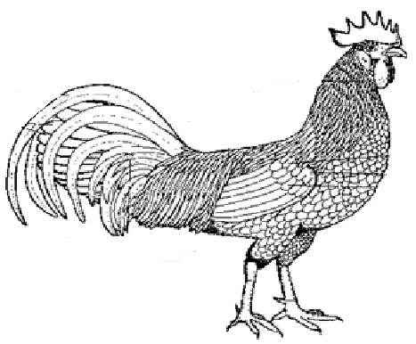

comb

tail

eyes wings

beak

Functions of parts

spur

claws

|  |  |
| --- | --- |
| **Part** | **Function** |
| Beak | - For picking food |
| Eyes | - For seeing |
| Spur | - For protection |
| Claws | - For protection |
| Wings | - For flying |
| Feathers | - Provide warmth to the bird |

## Activity

1. *Draw a bird and indicate the eye, beak, wings, claws and spur.*
2. *State the function of;*
   1. *Beak*
   2. *Spur*
   3. *Claws*
3. *Which part of a bird does this?*
   1. *Flying*
   2. *Provide warmth*
   3. *For seeing*

# LESSON 1: PARTS OF AN EGG

Embryo/germinal disc

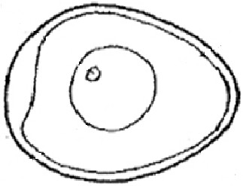

egg shell

egg membrane

air space

white egg/albumen

yolk

chalaza

# Functions of parts of an egg

|  |  |
| --- | --- |
| **Part** | **Function** |
| Germinal disc (embryo) | - Develops into a chick. |
| Yolk | - Source of proteins and fats to the  embryo. |
| Egg white | - Source of water and mineral salts to the  embryo. |
| Chalaza | * Supplies proteins and fats to the embryo. * It holds the yolk and embryo in position. |
| Egg shell | - Protects the inside parts of an egg. |
| Air space | - Allows gases exchange inside the egg. |

## Activity

1. *Draw the diagram of an egg and show the embryo, egg white, chalaza and yolk.*
2. *Which parts of an egg performs the following;*
   1. *Protects the inside parts of an egg.*
   2. *Allows gaseous exchange inside the egg.*
   3. *Source of water and mineral salts to the embryo*
3. *State the function of;*
   1. *Chalaza*
   2. *Germinal disc*
   3. *Egg yolk*

# LESSON 2: INSECTS

* Mosquitos
* Termites
* Grasshoppers
* Bees
* Tsetseflies
* Butterflies
* Houseflies
* Black flies
* Black ants
* White ants
* Cockroaches

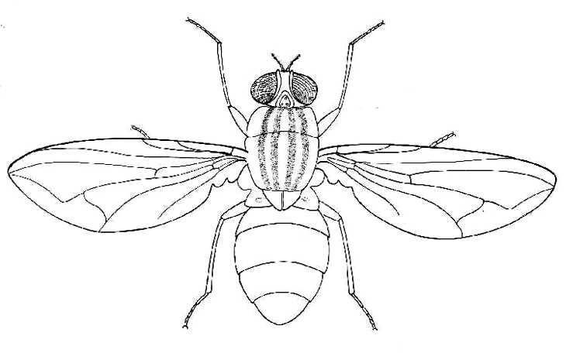

**an insect**

head

Compound eye

thorax

wing

abdomen

legs

haltere spiracles

oviposter

proboscis

Feelers/antennae

# Parts of

## Activity

1. *Name any six common insects in the environment.*
2. *In the space below, draw an insect and show;*
   1. *Spiracles*
   2. *Oviposter*
   3. *Wings*
   4. *Compound eyes*
3. *Suggest two uses of insects to man.*

# LESSON 3: FUNCTIONS OF PARTS OF AN INSECT

|  |  |
| --- | --- |
| **Part** | **Function** |
| Compound eyes | - Have simple eyes inside which enables vision. |
| Feeler | - For feeling on food like nectar. |
| Oviposter | - For laying eggs. |
| Wings | - For flying. |
| Stings | - For protection |
| Spiracles | - For breathing |
| Haltere | - For balancing in air during flight |

## Activity

1. *Identify the parts of an insect which perform the following roles;*
   1. *Flying.*
   2. *Detecting danger.*
   3. *Sucking liquid food like nectar.*
   4. *Balancing in air during flight.*
2. *State the function of the following parts to the insect.*
   1. *Compound eyes*
   2. *Sting*
   3. *Spiracles*
   4. *Haltere*
   5. *Oviposter*

# LESSON 4: CHARACTERISTICS OF INSECTS

* They have three main body parts i.e, head, thorax and abdomen.
* They have three pairs of jointed legs.
* They breathe through spiracle.
* They have one pair of compound eyes.

Characteristics of ticks/spiders (They are arachnids not insects)

* They have four pairs of legs (8 legs)
* They have 2 main body parts (cephalothorax and head)
* They breathe through booklungs.
* They don’t have compound eyes.

Features of an insect Head

* Compound eyes
* Proboscis/mandibles
* Feelers/antennae

Thorax

* Wings
* Legs
* Halters

Abdomen

* Spiracles
* Ovipositors
* Stings

## Activity

1. Name the three body parts of an insect.
2. State any three characteristics of insects.
3. Why are spiders not called insects?
4. Name any two features on an insect found at;
   1. Head
   2. Thorax
   3. Abdomen

# LESSON 5: GROUPS OF INSECTS

1. Social insects

These are insects that live and work together e.g bees, white ants, wasps, termites e.t.c.

1. Solitary insects

These are insects that don’t live and work together e.g mosquitoes, flies, dragon flies, locusts, cockroaches, preying mantists

Benefits from insects

* Some are eaten as food.
* Some pollinate flowers
* Bees provide honey and wax

## Activity

1. *Name two groups of insects.*
2. *What are social insects?*
3. *Give three examples of insects which live and work together.*
4. *What term refers to insects which do not live and work together?*
5. *Name three examples of solitary insects.*
6. *Identify three benefits of insects to man.*

# LESSON 6: INSECT HABITATS

What is a habitat?

|  |  |
| --- | --- |
| **Insect** | **Habitat** |

|  |  |
| --- | --- |
| Bees | Hive |
| White ants | Ant hill |
| Black ants | Soil |
| Mosquitoes | Stagnant water |
| Tsetsefly | Lakeside/river banks |
| Scorpion | Dry places/deserts |

How are insects harmful to us?

* They spread germs that cause diseases.
* They sting us.
* They spoil our crops.

How are some insects useful to us?

* They are sources of food.
* They pollinate flowers.
* They give us honey.
* They reduce the volume of feaces.

## Activity

1. *Explain the term habitat.*
2. *Name the habitats of the following insects;*
   1. *Bees*
   2. *Mosquitoes*
   3. *Termites*
   4. *Scorpions*
3. *Which insects live in the following places?*
   1. *Ant hill*
   2. *Lake sides*
   3. *Soil*
4. *Give three ways how some insects are harmful to people.*
5. *Give two usefulness of some insects to us.*

# THEME: LIVING THINGS

**TERM II**

# PLANTS IN OUR SUB – COUNTY

**LESSON 1: PLANTS AND THEIR HABITATS**

We have the following categories of plant habitats

* Garden/field
* Water
* Wetlands/swamps
* Dry places/deserts
* Rocky places

Examples of plants

* Maize plant
* Soya bean plant
* Simsim plant
* Sisal plant
* Eucalyptus plant
* Cactus plant
* Orange plant e.t.c.

Characteristics of plants

* They produce their own food through photosynthesis.
* They breathe through stomata.
* They produce by means of seeds or spores.
* They are divided into dicotyledonous and monocotyledon.
* They all contain chlorophyll.

## Activity

1. *Name any four places where we find plants.*
2. *Name six common plants we have in our community.*
3. *How are beans, cassava, maize related in terms of habitat?*
4. *Mention four characteristics of plants.*

# LESSON 2: PLANT HABITATS

Plants are categorized into different habitats depending on the suitability of the place for the plant for its life process.

1. Swamps/wetlands
   * Papyrus
   * Sugarcane
   * Rice
   * Cocoyam
   * Suds
   * water lilly
   * Water hyacinth e.t.c
2. Garden/field
   * Beans
   * Maize
   * Cassava
   * Simsim
   * Cotton
   * Coffee e.t.c
3. Rocky areas
   * Algae
   * Lichens
   * Spirogyra
4. Dry places
   * Cactus
   * Sisal
   * Casavinia

## Activity

1. *Name any two plant habitats you know.*
2. *Name three plants in the following categories.*
   1. *Wetlands/swamps*
   2. *Garden/fields*
   3. *Rocky areas*
   4. *Dry places*

# LESSON 3: PARTS OF A FLOWERING PLANT

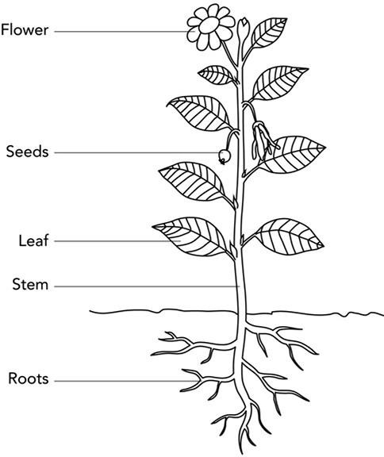

Fruit

## Activity

1. *Draw the flowering plant and indicate the flower, internods, roots and axillary bud.*
2. *Name two systems on a flowering plant.*

# LESSON 4: ROOTS

A root is a part of a plant that grows into soil.

Functions of roots to plants

* They fix and hold the plant firmly into the soil.
* They collect water and mineral salts from the soil.
* Some roots store food for the plant.

Functions of roots to man

* Some roots are eaten as food.
* They help to control soil erosion.
* Some roots are used as herbal medicine.

## Activity

1. What are plant roots?
2. Name two parts of a plant that belong to root system.
3. State four uses of roots to man.
4. How are roots useful to the plant?

# LESSON 5: TYPES OF ROOTS

1. Tap roots
2. Fibrous roots

Tap roots

It is formed when the radical forms a large main root with small lateral branches/roots.

They are found in leguminous plants like beans, g-nuts, soya beans, peas e.t.c

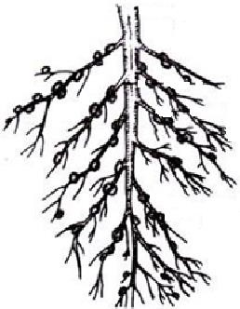

tap root

lateral roots

root nodules root hairs

root cap

Functions of the parts

|  |  |
| --- | --- |
| **Part** | **Function** |
| Root hairs | Absorbs water and mineral salts from the soil. |
| Root cap | Protects the young growing root from damage. |
| Tap root | Main root with many branches called lateral roots. |

## Activity

1. Name two types of roots.
2. What do we call roots formed when radical forms a large main root with small lateral roots?
3. Tap roots are found in leguminous crops, what are leguminous plants?
4. Give three examples of leguminous plants.
5. Draw a tap root and indicate root nodules, root hair, root cap, tap root.

# LESSON 6: FIBROUS ROOTS

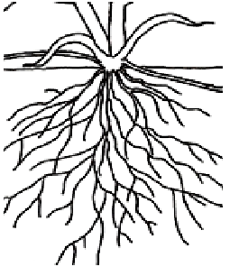These are roots that grow from the same point of a stem. They spread in many different directions but have the same size e.g. millet, maize, rice, sorghum, and elephant grass.

## Activity

1. *In the space provided below, draw a fibrous root.*
2. *Name four plants with fibrous root system,*
3. *How are roots useful to man?*
4. *State the function of;*
   1. *Root hairs*
   2. *Root cap*

# LESSON 7: TYPES OF STEMS

* Upright stems
* Underground stems
* Climbing or creeping stems

Examples of plants with upright/erect stems

* Mvule
* Rice
* Mahogany
* Eucalyptus
* Paw paw
* Coffee
* Maize
* Cassava e.t.c

Underground stems

These are stems which grow below the ground.

*Examples*

* Onions
* Irish potatoes
* Coco yams

 stem

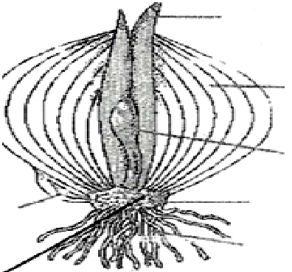

Foliage leaves

Flesh leaves Axillary bud

roots

Uses of stems to plants

* They hold the plant in order to get sunlight.
* Act as tubes to take water to leaves.
* Some stems store food for the plant.
* They hold flowers and fruits.

## Activity

1. *Name three types of stems.*
2. *Upright stems grow straight into the space. Name four crops with upright stems.*
3. *What are underground stems?*
4. *Name three crops with underground stems.*

# LESSON 1: CLIMBING STEMS

Plants with weak stems climb other plants in order to get enough support and sunlight.

They climb other plants in the following ways;

* Using tendrils
* Using hooks
* hooksBy twining or clasping

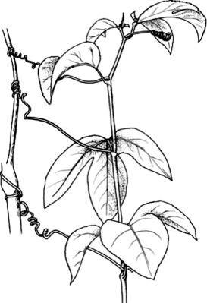tendrils

Uses of plant stems to man

* Most stems are used in building.
* Some stems are used as wood fuel.
* Some stems are eaten as food e.g sugarcane.
* Some stems act as herbal medicine.
* Some stems can be sold to get money e.g poles.

## Activity

1. *Suggest two reasons why plants with weak stems climb others?*
2. *Mention three ways how plants climb others.*
3. *List three uses of plant stems to man.*
4. *Write down two uses of items to plants.*

# LESSON 2: LEAVES

Leaves grow from the stems of plants. They contain a green substance called chlorophyll. It is a part of the plant where photosynthesis takes place.

*Structure of a leaf* apex

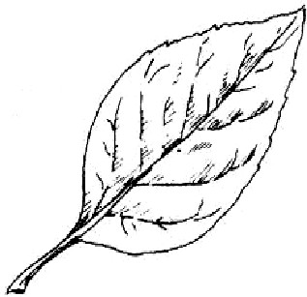

margin

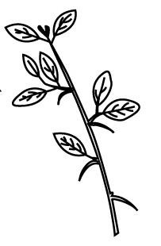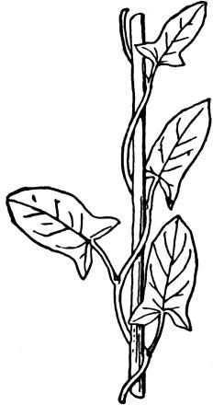

-

twining

hooks

main vein

Leaf stalk

stomata

vein

**Functions of parts of a leaf**

|  |  |
| --- | --- |
| **Part** | **Function** |
| Veins | - Transport plant nutrients and water to and from the leaf. |
| Lamina | - It is where photosynthesis takes place. |
| Stomata | * They open and close for gaseous exchange. * They allow water to get out of a plant during transpiration. |

## Activity

1. *What is a leaf?*
2. *Draw a diagram of a leaf and indicate the stomata, leaf blade, midrib and margin.*
3. *Give the function s of the following parts of a leaf;*
   1. *Veins*
   2. *Lamina*
   3. *stomata*
4. *How do we call the green substance found in leaves?*

# LESSON 3: TYPES OF LEAVES

1. Simple leaves

A simple leaf has one leaf blade on one leaf stalk.

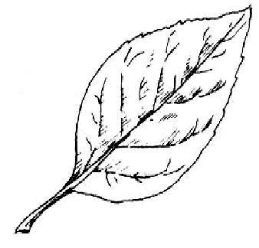

1. Compound leaves

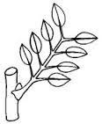A compound leaf is one with many leaflets on one leaf stalk.

Functions of leaves to plants

* Make food for the plant by photosynthesis.
* Some leaves store food and water for the plant.
* They allow gaseous exchange through stomata.
* Transpiration takes place in leaves.

Functions of leaves to man

* Some leaves are eaten as food e.g nakati
* Some leaves are sold for money.
* Some leaves are used as herbal medicine.

## Activity

* 1. *Name two types of leaves.*
  2. *How are simple leaves different from compound leaves?*
  3. *Give two examples of crops with;*
     1. *Simple leaves*
     2. *Compound leaves*
  4. *Write down two used to leaves to;*
     1. *Plants*
     2. *Man*

# LESSON 4: FLOWER

* It is a reproductive of a plant.
* It is used to produce fruits and seeds.
* It belongs to the shoot system of a plant in which reproductive cells (gametes) are produced.

*Parts of a flower*

petals style

stigma

anther head

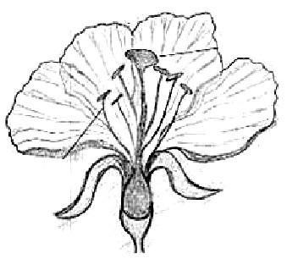

filament ovules

## Activity

1. *What is a flower?*

sepals flower stalk

1. *To which system in a plant does the flower belong?*
2. *Draw the diagram of a flower and show the stigma, ovary, sepal, ovules, anther, style and filament.*

# LESSON 5: FUNCTIONS OF PARTS OF A FLOWER

|  |  |
| --- | --- |
| **Part** | **Function** |
| Petals | * They are brightly coloured to attract pollinators. * A group of petals on a flower is called corolla. |
| Sepals | * They protect the flower in its bud stage before it opens. * A group of sepals on a flower is called calyx. |
| Anther | - Produces pollen grains (reproductive cells) |
| Stigma | - Receives pollen grains from anthers. |
| Filament | - Holds the anther in position. |
| Style | - Keeps the stigma upright. |
| Ovary | - Keeps the ovules and develop into a fruit. |
| Ovules | - Develop into seeds. |
| Flower stalk | - Holds the flower in an upright position. |

## Activity

1. *Name the use of petals on a flower.*
2. *What is corolla?*
3. *State the use of sepals on a flower.*
4. *What is calyx?*
5. *Where do male reproductive cells produced in a flower?*
6. *Give the use of;*
   1. *Ovary*
   2. *Ovules*
   3. *Flower stalk*

# LESSON 6: REPRODUCTION IN PLANTS

A flower is the reproductive part of a plant.

In a flower, there are both male and female reproductive part.

# Pistil

This is a collection of all female parts of a flower.

Stigma style

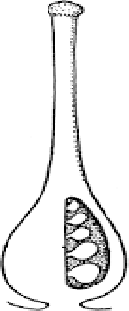

ovules

ovary

# Stamen

This is a collection of all male parts of flower.

anther head/pollen bag

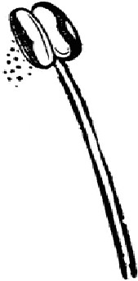

filament

# Anther

They are pollen bags that bear pollen grains.

# Filament

They support anthers to produce pollen grains

## Activity

* 1. *What is a pistil?*
  2. *Write down three components of pistil.*
  3. *What do we call the collection of all male parts of a flower?*
  4. *Name two components of a stamen.*
  5. *Draw diagrams to illustrate;*
     1. *Pistil*
     2. *Stamen*

# LESSON 7: USES OF FLOWERS

* They are used to get/make perfumes.
* They are used for decoration on functions/parties.
* Flowers are used to make insecticides.
* Farmers sell flowers and get money.
* They produce sweet juice called nectar which bees use to make honey.
* They produce seeds to continue the life of plants.
* They are given to friends as gifts.

# HOW TO CONSERVE AND PROTECT PLANTS

* Electrification of all places to reduce wood fuel exploitation.
* Government should set strict laws against cutting trees for timber.
* Teach the people about the uses of plants in the community.
* People need to practice re-afforestation.
* Keep the plant species in botanical gardens.

## Activity

1. *Name the plant juice bees get from flowers.*
2. *What is the use of nectar to bees?*
3. *List four uses of flowers.*
4. *Suggest three ways of conserving and protecting plants.*
5. *Suggest one way young children can contribute to the protection and conservation of trees.*

# LESSON 1: HOW DANGEROUS SOME PLANTS ARE TO US

* Some plants are thorny hence the damage our skin
* Some plants are poisonous
* Some plants have bad smell and cause skin irritation infection.

# EXPERIMENT

* Observing and recording the growth of a plant.
* Learners plant seeds in a tin and keep daily record of the growth of the seedling.
* This should be done under close supervision of the teacher.

## Activity

1. *Mention any three dangers of some plants to man.*
2. *In observing and recording growth of a plant, suggest three needs of a growing plant.*
3. *Suggest three ways children can care for seedlings.*
4. *Write two things children can use in providing care for seedlings.*

# LESSON 2: CROP GROWING PRACTICES

These are activities done for a crop farm to ensure high and good yields. They include:-

1. Pruning

This is the cutting of excess and unproductive parts from a plant.

1. Thinning

This is the removal of excess and poor growing seedling in a nursery bed and plants in a garden

1. Plant training/staking

This is the helping plants grow upright using stick frames.

1. Weed control/weeding

This is the removal of unwanted plants from a garden.

1. Mulching

This is the covering of top soil with dry grass.

1. Spraying

This is the control of pests and diseases by the use of chemicals.

1. Crop rotation

This is the growing of different types of crops on the same piece of garden season after season.

1. Land cleaning

This is the cutting down trees and bush in order to get land ready for ploughing/digging.

1. Seed selection

This is choosing a particular variety of seeds for planting.

## Activity

* 1. *What do we call the act of cutting excess and unproductive branches from a plant?*
  2. *What is thinning?*
  3. *What term describes the act of covering top soil with dry grass.*
  4. *Define;*
     1. *Crop rotation*
     2. *Seed selection*
     3. *Plant training/staking*
     4. *Weeding*
  5. *Suggest two reasons why mulching is done.*

# LESSON 3: CARING FOR CROPS

Crops need intensive care so that they grow well and produce good quality yields. We can care for crops in the following ways;

1. Watering

Crops need water for healthy growth.

Water can be given to crops artificially if rain is not enough and it is done always in the evening.

1. Weeding

This is the removal of unwanted plants in a garden.

This creates enough space for crops to grow and get enough nutrients from the soil.

1. Spraying

This is the control of pests and diseases by the use of chemicals on crops.

1. Staking/plant training

Plants with weak stems need to be given extra support in order to grow upright and protect them from damage by pests when they’re on the ground.

1. Pruning

This is the removal of excess and unproductive branches from a plant. This is done to reduce the plant weight, reduce the rate of transpiration and utilization of plant nutrients.

1. Mulching

This is the covering of top soil with dry plant materials.

This is done to control growth of weeds and prevent the loss of moisture from the soil.

## Activity

* 1. *What is mulching?*
  2. *Give two reasons why a farmer can carry out mulching.*
  3. *Define pruning.*
  4. *Suggest one disadvantage of not pruning plants.*
  5. *Explain the term weeding.*
  6. *Apart from mulching, pruning and weeding, give three other ways of caring for crops.*

# LESSON 4: CROP ROTATION

This is the growing of different crops on the same piece of garden season after season.

*Diagram to illustration crop rotation*

Beans A

Maize Cabbage

B D

Tomatoes C

Advantages/importance of crop rotation

* It maintains soil fertility
* It starves pests
* It destroys the life cycle of pests
* It controls soil erosion and soil exhaustion
* It maintains high crop yields

## Activity

1. *Explain the term crop rotation.*
2. *Using the given crops, design a crop rotation and draw the diagram.*
3. *Mention four advantages of rotating crops seasonally on the same piece of land.*
4. *Suggest two dangers a farmer can meet if he doesn’t carry out crop*

*rotation.*

# LESSON 5: GARDEN TOOLS

These are tools/equipments used to do work on a farm. Examples of garden tools and their uses.

|  |  |
| --- | --- |
| **Tool** | **Uses** |
| Rake | * For smothering the soil for planting. * For collecting weeds. |
| Axe (hatchet) | * For rough chopping. * For cutting big trees. |
| Panga | * For clearing the bush. * For cutting small trees. |
| Hoe | * For digging. * For weeding and planting. |
| Sickle | * For harvesting cereals. * For cutting weeds and grass. |
| Trowel | - For transplanting seedlings. |
| Shears | - For trimming and pruning plants. |
| Watering can | - For watering crops. |
| Pick axe (mattock) | - For digging rocky ground. |
| Wheel barrow | - For carrying harvested crops, manure e.t.c |

## Activity

1. *What are garden tools?*
2. 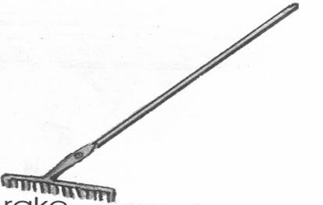*State the use of;*
   1. *Rake*
   2. *Panga*
   3. *Sickle*
   4. *Trowel*
   5. *Hoe*
   6. *Axe*
3. *Which garden tool is used for;*
   1. *Digging rocky ground.*
   2. *Carrying harvested crops and manure.*
   3. *Watering crops.*
   4. *Trimming and pruning plants.*

# LESSON 6: GARDEN TOOLS

*Diagrams of different garden tools and their names*

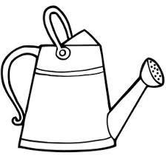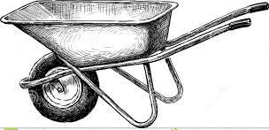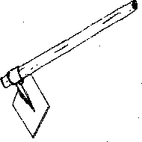



Caring for garden tools

* Clean garden tools after use.
* Keep them in a clean dry place.
* Paint tools to prevent rusting.
* Tools should be used for their right purpose.
* Cutting and digging edges should be sharpened properly.
* Oiling/greasing to prevent rusting.

# LESSON 7: SCHOOL GARDEN

A crop is a plant grown and cared for by man.

A farmer is a person who grows crops and rears animals.

A farmer should consider the following when planning to have garden tools;

* Enough seeds
* Garden tools
* Land make up.

Why is a school garden important to school children?

* Children learn how to dig.
* Children get food and fruits to eat.
* Excess food can be sold to get money.
* Children learn how to grow crops.
* Children learn how to care for crops.

Examples of crops that school children grow in a school garden.

* Beans
* Maize
* Sugarcane
* Rice
* Tomatoes
* Cabbages
* Onions
* Groundnuts

## Activity

1. *Explain the following terms.*
   1. *Farmer*
   2. *Farm*
   3. *Farming*
2. *Write down two needs of a farmer when planning to have a garden.*
3. *Mention four importance of a school garden to children.*
4. *Give four examples of crops school children can grow in a school garden.*

# LESSON 1: NURSERY BED

A nursery bed is a place where seeds are first planted and developed into seedlings before being taken to the main garden.

How to prepare a nursery bed

* Clear the bush
* Dig the soil
* Make the soil smooth and fine
* Add manure
* Make lines and put seeds into the soil

Crops first planted in a nursery bed are;

* Cabbages
* Onions
* Rice
* Tomatoes
* Egg plants
* Green pepper
* Coffee
* Pawpaw

Importance of a nursery bed

* It protects the seedlings from strong sun rays and heavy rainfall (bad weather).

Transplanting is the removal of a seedling from a nursery bed to the main garden.

It is done in the evening to prevent them from losing more water that it is able to absorb.

## Activity

1. *Define a nursery bed.*
2. *Mention two ways how a farmer is able to prepare a nursery bed.*
3. *List four crops that are first planted in the nursery bed.*
4. *How do we call the removal of seedlings from a nursery bed to the main garden?*
5. *What is the best time for transplanting seedlings?*

# LESSON 2: GROUPS OF CROPS

cereal crops are crops which produce grains e.g millet, maize, sorghum, rice, barley, wheat e.t.c

Fruit crops e.g oranges, guavas, mangoes, apples e.t.c

Legumes are crops with roots that have root nodules e.g groundnuts, peas, beans, soya beans.

Vegetables e.g cabbages, nakati, spinach, dodo e.t.c

Root crops are crops that store food in roots e.g cassava, sweet potatoes, carrots e.t.c

## Activity

1. *How are cereal crops different from legumes?*
2. *Mention atleast three examples of crops below.*
   1. *Fruit crops*
   2. *Vegetable crops*
   3. *Root crops*
   4. *Cereal crops*
3. *What are root crops?*

# LESSON 3: CROP PESTS AND DISEASES

A pest is a living organism that destroys crops. Examples of pests are;

* Monkeys
* Squirrels
* Army worms
* Locusts
* Grasshoppers
* Birds
* Caterpillars e.t.c

Types of pests

Field pests are living organisms that destroy crops in the garden e.g monkeys, birds, locusts e.t.c

Storage pests are living organisms that destroy harvested crops in the store

e.g rats, weevils e.t.c

## Activity

* 1. *Define a pest.*
  2. *Mention two types of pests.*
  3. *List atleast two examples of;*
     1. *Garden pests*
     2. *Storage pests*

# LESSON 4: EXAMPLES OF CROP DISEASES

A disease is a condition that makes the something un well. Examples of crop diseases

* Cassava mosaic
* Bean rust
* Maize streak
* Bacteria wilt
* Tomato blight
* Leaf spot e.t.c

Control of pests and diseases

* By spraying
* By use of traps
* By using crop rotation
* By uprooting and burning infected crops
* By planting resistant crops
* By use of scare crops
* By timely planting
* By fencing

Importance of growing enough crops in a family

* It controls femine in the family
* Surplus food is sold to get money

## Activity

1. *What is a disease?*
2. *List four diseases that attack the crops.*
3. *Which disease attacks the following crops;*
   1. *Cassava*
   2. *Beans*
   3. *Maize*
   4. *Tomatoes*
4. *Mention three ways how a farmer has controlled pests and diseases.*

# TERM III LESSON 5:

**THEME: HEALTH IN OUR SUB – COUNTY TOPIC: VECTORS AND DISEASES**

A Vector is a living organism that spreads disease causing germs. Germs are also called pathogens.

Examples are;

* Houseflies
* Snails
* Mites
* Ticks
* Mad dogs/cats
* Mosquitoes
* Tsetse flies
* Rats e.t.c

A germ is a living organism which causes diseases Types of germs

* Bacteria
* Virus
* Protozoa
* Fungi

## Activity

1. *Define;*
   1. *A vector*
   2. *A germ*
2. *What is another name for a germ?*
3. *Mention five vectors found in the environment.*
4. *List atleast two types of germs.*

# LESSON 6: HABITAT OF GERMS

Places where we find germs are;

* Latrines/toilets
* Air
* Infected blood
* Animal’s body
* Saliva
* Dirty places
* Soil e.t.c

How germs enter our bodies

* Through animal bites
* Through drinking contaminated water
* Through eating dirty food
* Through blood transfusion. (This is the process of putting blood from one

person’s body into the body of someone else.

* Through the 4f’s
* Through open cuts and wounds
* Through body contact
* Through air

## Activity

1. *Mention five places where germs are found.*
2. *Suggest five ways how germs enter the body.*
3. *What is blood transfusion?*

# LESSON 7: HOUSEFLIES

Houseflies are vectors because they spread diseases like cholera, diarrhea, dysentery, typhoid, trachoma.

Places where houseflies are found

* Latrines
* Rubbish pits
* Rotten food

Ways through which flies spread germs

* Through 4 F’s (feaces, flies, food, finger)

Ways of controlling houseflies

* Washing utensils after eating food
* Proper disposal of feaces and urine
* By covering food
* By covering latrines
* By washing fruits before eating them
* By constructing ventilated improved latrines

## Activity

1. *Mention three diseases spread by houseflies.*
2. *List two places where houseflies are found.*
3. *Write the 4 F’s in full under their correct order.*
4. *How can houseflies be controlled in a home. (Give three ways)*

# LESSON 1:

**STRUCTURE OF A HOUSEFLY (Refer to week seven lesson 2)**

# Functions of parts of a housefly (Refer to week seven lesson 2)

**LESSON 2:**

# LIFE CYCLE OF A HOUSEFLY

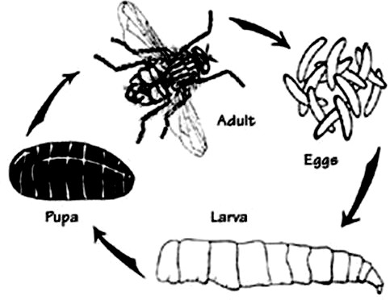They undergo four stages of growth called complete life cycle. (eggs , larva , pupa , adult)

## Activity

1. *List the four stages of life cycle of an insect.*
2. *Draw the stages of a n insect and name them.*

# LESSON 3: CHOLERA

Cholera is a disease caused by a germ called a bacteria. The bacteria that causes cholera is called vibrio cholera. It kills within 6 – 24 hours if it is not treated.

How cholera spreads

* Through 4 F’s
* Through eating food with unwashed hands
* By not washing hands after using the latrine
* By drinking unboiled water
* Poor disposal of human wastes

Signs and symptoms

* Severe vomiting
* Severe diarrhea

Ways of preventing cholera

* By washing hands before handling food
* By washing hands after visiting the latrine/toilet
* By drinking boiled water
* By having proper disposal of human wastes

## Activity

1. *Which germ causes cholera?*
2. *Name the type of bacteria that causes cholera.*
3. *Mention three ways how cholera spreads.*
4. *List the two signs of cholera.*
5. *In which way can one prevent the spread of cholera?*

# LESSON 4: TYPHOID

Typhoid is caused by a bacteria called salamonella typhi through eating stale food.

Signs and symptoms

* Vomiting
* Fever with headache
* Stomachache (abdominal pain)
* Diarrhea

How typhoid is prevented

* By boiling water
* Proper disposal of human waste
* By eating warmed food
* By washing hands before handling food
* By covering all food and drinks
* By washing hands with water and soap after using the latrine

## Activity

1. *Which type of bacteria causes typhoid?*
2. *Mention three signs and symptoms of a person with typhoid.*
3. *In which four ways can typhoid be prevented at home?*

# LESSON 5: DYSENTERY

Dysentery is the passing out of watery stools with blood stains.

Dysentery is caused by;

1. A bacteria called bacillary dysentery
2. A protozoa called amoeba which is also called amoebic dysentery

How dysentery spreads

* By drinking unboiled water
* By not washing hands after using the latrine
* By handling food with dirty hands
* By bathing in ponds
* Through 4 F’s
* By eating contaminated food

Signs and symptoms

* Defecation of watery stool with blood
* Painful defecation
* Fever and headache

How to prevent dysentery

* Proper disposal of human wastes
* By eating clean food with clean hands
* By drinking boiled water
* By washing hands after visiting the latrine

## Activity

1. *Define dysentery.*
2. *Mention the two germs that cause dysentery.*
3. *Give two ways how dysentery is spread.*
4. *List two signs and symptoms of a person with dysentery.*
5. *In which way can dysentery be prevented in a home?*

# LESSON 6: TRACHOMA

Trachoma is a disease that attacks the eyes. It is caused by a virus called Chlamydia spread by a housefly.

How trachoma spreads

* Through sharing handkerchiefs with an infected person
* Through sharing of towels with an infected person
* Through shaking hands with an infected person
* Through sharing basins with an infected person Signs and symptoms
* Reddish /pinkish eyes
* Irritations in the eyes
* Burning sensation in the eyes
* Pus discharge out of the eyes

How to control and prevent trachoma

* Wash the eyes with clean water and soap.
* By not sharing towels, handkerchiefs, basins with infected persons.
* Treating infected persons in time.

## Activity

1. *Which part of the body does trachoma attack?*
2. *Name the vector that spreads trachoma.*
3. *How is the germ that spreads trachoma different from that of cholera?*
4. *Mention four ways how trachoma spread from one person to another.*
5. *In which 3 ways can one prevent the spread of trachoma?*

# LESSON 7: DIARRHOEA

Diarrhoea is the frequent passing out of watery stool. It is either caused by a bacteria, virus or worms.

Symptoms/signs of diarrhoea

* Stomachache
* Passing out of watery stools
* Lose of weight and appetite to food

How diarrhea spreads

It spreads through the 4 F’s

Effects of diarrhoea

* Causes dehydration

## Activity

1. *What is diarrhoea?*
2. *Name two germs that cause diarrhoea.*
3. *Write the 4 F’s in their correct order.*
4. *Give one effect of severe diarrhoea.*
5. *What are the two signs and symptoms of a person with diarrhoea?*

# LESSON 1: DEHYDRATION

Dehydration is a condition where the body doesn’t have enough water.

Causes of dehydration

* Severe diarrhoea
* Severe vomiting Signs of dehydration
* Sunken eyes
* Dry mouth
* Sunken spot on the babies head
* Little or no urine passed
* A pinch of skin taken goes back slowly to its shape
* The person is sleepy

Prevention of dehydration

* Give the patient a lot of fluids like juice, ORS, water e.t.c

## Activity

1. *What is dehydration?*
2. *Mention two causes of dehydration.*
3. *What are the five signs of a person with a condition of dehydration?*

# LESSON 2: MAKING OF ORS

Oral Rehydration Salts

It is a rehydration solution because it is used to rehydrate people by passing the solution through the mouth.

It replaces the lost water in the body. How to prepare ORS

* Wash your hands with water and soap.
* Measure one litre of drinking water in a clean container.
* Measure one leveled teaspoon of salt into the water
* Add eight leveled teaspoons of sugar
* Stir the mixture until all the salt and sugar disappear completely.
* Taste the solution to find out where it is very salty or not. Components of ORS
* Sugar
* Salt
* Water
* S.S.S in full

Sugar Salt Solution (This is the mixture of salt and sugar in drinking water)

## Activity

1. *What is ORS in full?*
2. *Why is ORS also called SSS?*
3. *Name the first four steps of preparing ORS.*
4. *Mention the three components of ORS.*
5. *What amount of sugar and salt can be used in preparing ORS?*
   1. *Sugar*
   2. *Salt*

# LESSON 3: MOSQUITOES

There are three types of mosquitoes;

1. Anopheles mosquito
2. Culex mosquito
3. Aedes/tiger mosquito

|  |  |
| --- | --- |
| **Mosquito** | **Disease spread** |
| Female anopheles mosquito | Malaria |
| Culex mosquito | Elephantiasis |
| Aedes mosquito | Yellow fever |

**External features of a mosquito**

thorax wings

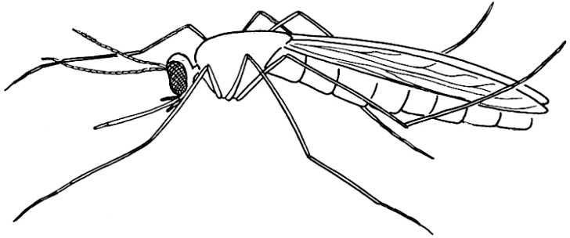

probosci

## Activity

legs

abdomen

1. *Name the three types of mosquitoes.*
2. *Which types of mosquito spreads the following diseases?*
   1. *Malaria*
   2. *Elephantiasis*
   3. *Yellow fever*
3. *Draw a mosquito and indicate the following parts on it proboscis, wings, abdomen and leg.*

# LESSON 4: MALARIA

Malaria is a disease spread by a female anopheles mosquito. It is caused by a germ called plasmodia.

Signs and symptoms of malaria

* Headache
* Pain in the joints
* Stomachache
* High temperature (fever)
* Vomiting
* Body weakness

Prevention and treatment of malaria

* Drain stagnant water near our homes
* Spraying insecticides to kill malaria
* Sleeping under treated mosquito nets
* Pouring oil on stagnant water
* Early treatment of malaria
* Having nets in windows, doors and ventilation
* Closing doors and windows early in the evening before dark

Malaria can be treated with both factory made drugs and herbal drugs. Avoid self medication but consult a health worker.

## Activity

1. *Name the vector that spreads malaria.*
2. *Which germ causes malaria?*
3. *List four signs and symptoms of a person with malaria.*
4. *Mention four ways how malaria can be prevented.*

# LESSON 5: LIFE CYCLE OF ANOPHELES MOSQUITO

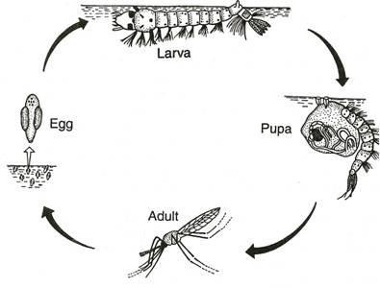The mosquito undergoes a complete life cycle i.e eggs , larva , pupa , adult

## Activity

1. *Which type of life cycle does a mosquito undergo?*
2. *In the space provided draw all the stages of life cycle a mosquito undergoes.*

# LESSON 6: CONTROL OF MALARIA WITHOUT USING DRUGS

* Drain stagnant water near our homes.
* Spraying insecticide in houses to kill adult mosquitoes
* Sleeping under treated mosquito nets
* Pouring oil on stagnant water.

Drugs to treat malaria

* Fansidar
* Chloroquine
* Lumatem
* Quinine
* Coatem
* Aloevera
* Mululuza

## Activity

1. How can one control malaria without the use of drugs?
2. List at least four drugs used to treat malaria in human beings.

# LESSON 7: LIFE CYCLE OF A CULEX /AEDES MOSQUITO

They also undergo complete life cycle i.e eggs , larva , pupa , adult

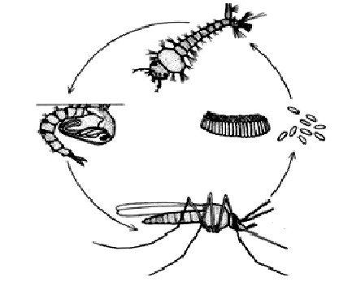larva

pupa eggs

## Activity

adult

1. *Name the stages of growth of an aedes mosquito.*
2. *In the space provided, draw and name the stages of an aedes mosquito.*
3. *Which diseases do the mosquitoes below spread?*
   1. *Culex mosquito*
   2. *Aedes mosquito*

# LESSON 1: COCKROACHES

These are insects with flat bodies, dark brown in colour and they are active at night.

The live in dark corners in houses, cupboards, wall cracks, clothes and in latrines.

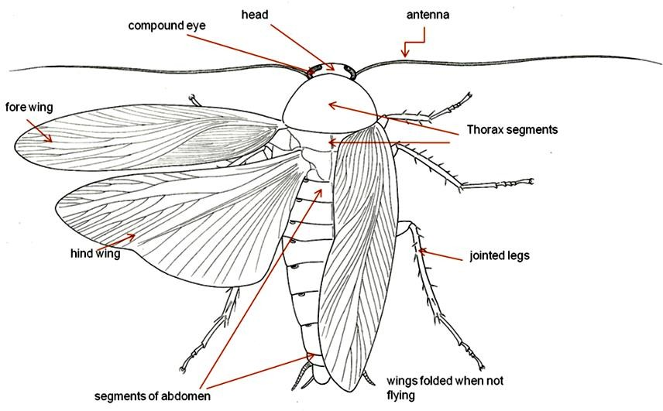

# LESSON 2: LIFE CYCLE OF A COCKROACH

Cockroaches undergo incomplete life cycle i.e eggs , nymph , adult

Other insects that undergo incomplete life cycle are; locusts, grasshoppers.

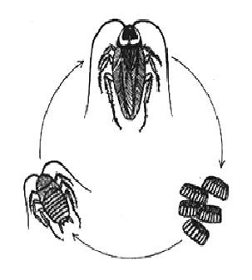adult

nymph

eggs

Diseases spread by a cockroach

* diarrhea
* typhoid
* dysentery
* polio
* cholera

## Activity

1. Mention four places where cockroaches are commonly found.
2. Name atleast three diseases spread by a cockroach.
3. Draw the structure of a cockroach and name the following parts; thorax, antenna, ovipositor.
4. Which type of life cycle does a cockroach undergo?
5. Draw the life cycle of a cockroach and name all the stages.
6. List two insects that undergo incomplete life cycle.

# LESSON 3: TSETSE FLIES

Tsetse flies look like houseflies but they are bigger in size. It crosses its wings when at rest.

It uses the sharp proboscis for sucking blood. They spread protozoa germs called trypanosome

Trypanosome germs cause sleeping sickness to man and nagana to cattle.

Life cycle of a tsetse flies

The eggs of a tsetse fly hatch into larvae inside the female tsetse fly.

The larva is passed out on the ground in the shade and makes a hole in the ground where it grows into a pupa. The pupa turns into an adult tsetse fly.

## Activity

1. *Which structure does a tsetse fly use to suck blood?*
2. *Name the germ that causes sleeping sickness.*
3. *Which stage of a tsetse fly is not shown on its life cycle?*
4. *How long does an adult tsetse fly spend to give birth to a larva?*
5. *Name the two diseases spread by a tsetse fly.*

# LESSON 4: SLEEPING SICKNESS (Nagana in animals)

Sleeping sickness is a disease spread by a tsetse fly and caused by germs called trypanosome.

Signs and symptoms

A person with sleeping sickness;

* Has fever from time to time.
* Feels weak in the body and sleepy all the time.
* Doesn’t want to eat.
* Looses weight.

Prevention and control of sleeping sickness (nagana)

* Use tsetse fly traps
* Spraying with insecticide
* Cleaning bushes near home
* Avoid grazing animals very early in the morning and late in the evening
* Keeping away from forests where tsetse flies as known to be
* Keeping away from bushes around water sources.
* Protecting the body by wearing trousers and long sleeved clothes in places where tsetse flies.

## Activity

1. *Which vector spreads nagana in animals?*
2. *List four signs and symptoms of a person sleeping sickness.*
3. *Mention four ways how tsetse flies can be controlled in our community.*

# LESSON 5: RIVER BLINDNESS

River blindness is caused by germs called filarial worms.

River blindness is spread by vectors called black fly. They are commonly found on fast streams like rivers. It attacks the eyes

Signs and symptoms

* Skin rash
* Severe itching of eyes
* Red watery eyes
* Bumps on the skin and legs

Prevention and control of river blindness

* Use insecticides to kill black flies or their larvae
* Have the infected person treated

## Activity

1. *Name the germ and vector of river blindness;*
   1. *Germ*
   2. *Vector*
2. *On which part of the body does river blindness attack.*
3. *List two signs and symptoms of a person with river blindness.*
4. *Give one way how river blindness can be prevented.*

# LESSON 6: OTHER DISEASE VECTORS

|  |  |
| --- | --- |
| **Vector** | **Disease spread** |
| Itch mite | Scabies |
| Lice | Relapsing fever |
| Ticks | Typhus fever |
| Rat fleas | Bubonic plague |
| Water snails | Bilharzia |

Ways of preventing vectors

* Proper disposal of human waste.
* Wash hands with clean water and soap after visiting latrines.
* Always sleep under treated mosquito net.
* Drain all the stagnant water near our homes.
* Clear the bush around our homes.
* Spray houses with insecticides.
* Drink clean boiled water always.

## Activity

1. *Fill in the blank spaces with the correct word.*

|  |  |
| --- | --- |
| ***Vectors*** | ***Disease spread*** |
| *Itch mites Nagana* | *River blindness* |

1. *Mention six ways how one can prevent vectors in our homes.*

# LESSON 7: HIV/AIDS

HIV in full

1. - Human
2. - Immunodeficiency V - Virus

AIDS in full

A - Acquired (to get)

I - Immune (protected against) D - Deficiency (lack of)

S - Syndrome (signs/symptoms)

Effects of HIV/AIDS on a victim/sick person

* AIDS has caused many people die.
* AIDS has led to increased number of orphans, widows and widowers.
* AIDS has led to mass poverty.
* AIDS has caused a lot of misery and hatred among the population for the loss of their loved ones.

## Activity

1. *What is;*
   1. *HIV in full*
   2. *AIDS in full*
2. *Which germ causes AIDS to man?*
3. *Which other term describes the group of signs and symptoms od diseases?*
4. *Mention three effects of IDS/HIV on a victim.*

# LESSON 1: HOW HIV/AIDS spreads

* The practice of sharing wives in a family
* The practice of tattooing
* Through sexual intercourse with an infected person.
* Through blood transfusion with infected blood.
* From an infected mother to a new baby at birth.
* Through sharing sharp piercing instruments with infected person like razor blade, safety pins e.t.c

How to care for HIV/AIDS patients

* Proper hygiene conditions should be provided to patients.
* Provide enough time for patients to rest by assisting them with house work.
* Provide good feeding to patients.
* Provide treatment to any particular disease identified.
* Counseling services should be provided.

## Activity

1. *Which African traditional practices lead to the spread of AIDS/HIV?*
2. *What other practices does AIDS spread other than traditional practices.*
3. *Mention four ways how HIV/AIDS patients are cared for.*

# PIASCY

PIASCY in full

P - Presidential

I - Initiative on

A - AIDS

S - Strategy for

C - Communication to Y - Youth

PIASCY messages

* Avoid bad peer groups
* Say no to gifts for sex
* Avoid bad touches

## Activity

1. *What is PIASCY in full?*
2. *Which president initiated PIASCY?*
3. *List at least three messages found in PIASCY to the youth.*

# LESSON 3: PERSONAL HYGIENE

Personal hygiene is the general cleanliness of our body and the things we use.

Importance of personal hygiene

* It prevents diseases like skin diseases, diarrhoea/ diseases e.t.c
* It prevents bad smell on our body.
* It helps to remove germs from our body.
* It helps to keep our body clean.
* It helps to remove hiding places for germs. Ways of keeping our body clean
* Bathing regularly
* Ironing clothes
* Washing hands oftenly as possible
* Cut finger nails short
* Brushing our teeth after meals

## Activity

1. *What is personal hygiene?*
2. *How is proper personal hygiene important?*
3. *Mention five ways how you can improve proper personal hygiene.*

# LESSON 4: IMPORTANCE OF BATHING DAILY

* It helps to remove dirt.
* To remove vectors e.g. lice, bedbugs
* Helps to remove bad smell
* It kills germs and vectors from the clothes

## Activity

1. *Mention two importance of;*
   1. *Bathing daily*
   2. *Brushing teeth*
   3. *Washing clothes*
   4. *Washing hands*

# LESSON 5: FAMILY HYGIENE

Family hygiene is the keeping family members and the home clean. Activities done to promote family hygiene

* Preparing food well and keeping it clean
* Serving food in a clean place
* Serving from clean utensils
* Washing clothes regularly
* Constructing latrines and keeping them clean
* Burning rubbish at the rubbish pit Dangers of poor personal hygiene
* Causes bad smell
* It can lead to easy spreading of diseases e.g. cholera, diarrhoea scabies, dysentery, typhoid etc.
* It attracts vectors that spread diseases e.g. houseflies, lice, bedbugs etc.

# Activity

1. *What is family hygiene?*
2. *Mention five activities done to promote proper family hygiene.*
3. *Give three dangers of poor personal hygiene.*